 

**RECIPE RECGNITION SYSTEM USING IBM WATSON STUDIO**

A PROJECT REPORT

Done as a part of Externship Program in **SMART INTERNZ**

Submitted By

D.Vasavi sri priya Roll No:19481A0551

B.Pushyami Roll No:19481A0528

B.Chandra babu Roll No:19481A0512

D.Ajay Yeswanth RollNo:19481A0547

of

School of Computing Sciences and Engineering

IN

Seshadri Rao Gudlavalleru Engineering college, Gudlavalleru.

1.INTRODUCTION

1.1 Overview

Food is an essential component of our individual and social life. Eating habits have a direct impact on our health and wellbeing, while ingredients, flavor and cooking recipes shape specific that are part of our personal and collective cultural identities. But there are also interesting applications of automatic food recognition to self-service restaurants and dining halls. For instance, accurate detection and segmentation of the different food items in a food tray can be used for monitoring food intake and nutritional information, and automatic billing to avoid the cashier bottleneck in self-service restaurants.

1.2 Purpose

The Project aims to build a web application that recognizes the recipe of the food items. Food recognition technology, if developed well, may help people gain insights into the food they consume resulting in a healthier and more satisfying diet. However, finding nutritious, satisfying and easy to cook food may not be an easy task for many. So we created an application to help them to find nutritious food for their healthier diet. Using CNN which in turn identifies the recipe of the recognized food item.

2.LITERATURE SURVEY

2.1 Existing system:

* An appropriate food recipe must require serving the real taste of the food and a balanced diet, and healthy life.
* As we all know, health is wealth, so food selection is essential for better health. Sometimes people pick some ingredient that they do not even know their names. Or pick up some ingredients from a grocery store, but they do not know how to make recipes using those ingredients.
* People should know which ingredients can be mixed and make delicious recipes.
* For a beginner, it is very challenging to select a recipe just by seeing the ingredients. Even for an expert cook, it is also problematic.
* In this project, we try to solve this problem. The work deals with the problem of automated recognition of an appropriate recipe.

2.2 Proposed system:

* As we all know, health is wealth, so food selection is essential for better health.
* Food category classification is a key technology for many food-related applications such as monitoring healthy diet, computational cooking, food recommendation system, etc.
* In this project, we focus on applications of automatic food recognition and identify the recipe in food by using convolutional neural networks.
* This model will classify images into food categories and to output a matching recipe.

3.THEORETICAL ANALYSIS

3.1 Block diagram:

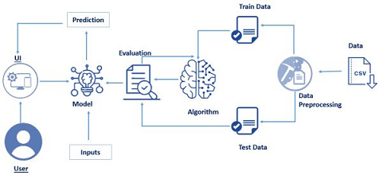

3.2 Software/ Hardware Designing:

Hardware Requirements:

* Processor : Intel Core I3
* RAM : 8.00 GB
* Storage 250 GB
* OS : Windows/Linux/MAC

Software Requirements:

* Operating System : Windows 10 Home
* Anaconda navigator: Anaconda must be installed as it provides jupyter notebook and Spyder.
* IBM Academic initiative account is required to access IBM Services
* IBM Watson Studio IBM Watson Studio helps data scientists and analysts prepare data and build models at scale across any cloud.
* IBM Watson Machine Learning - IBM Watson Machine Learning helps data scientists and developers accelerate Al and machine-learning deployment.
* IBM Cloud Object Storage IBM Cloud Object Storage makes it possible.

4.EXPERIMENTAL INVESTIGATION

We will be creating and testing our model for predicting which algorithms can give more accuracy to identify the recipe of the food item. Since there are multiple algorithms, we are using deep learning algorithms to build our model, we will compare the accuracy scores after testing and pick the most accurate algorithm.

From the list, we are using Convolutional Neural Network which gives the highest accuracy and selected it as our algorithm of choice for future use. On the basis of results, we have done the conclusion the convolutional neural network is the most accurate model which we have tested.

5.FLOW CHART

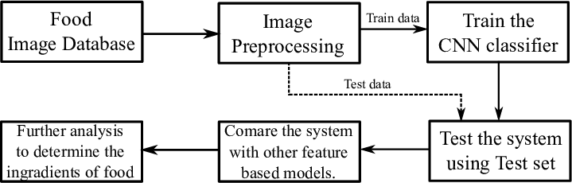

6.RESULT

The final result of the recipe recognition system was predicting the appropriate recipe of the food items.

HOME PAGE:

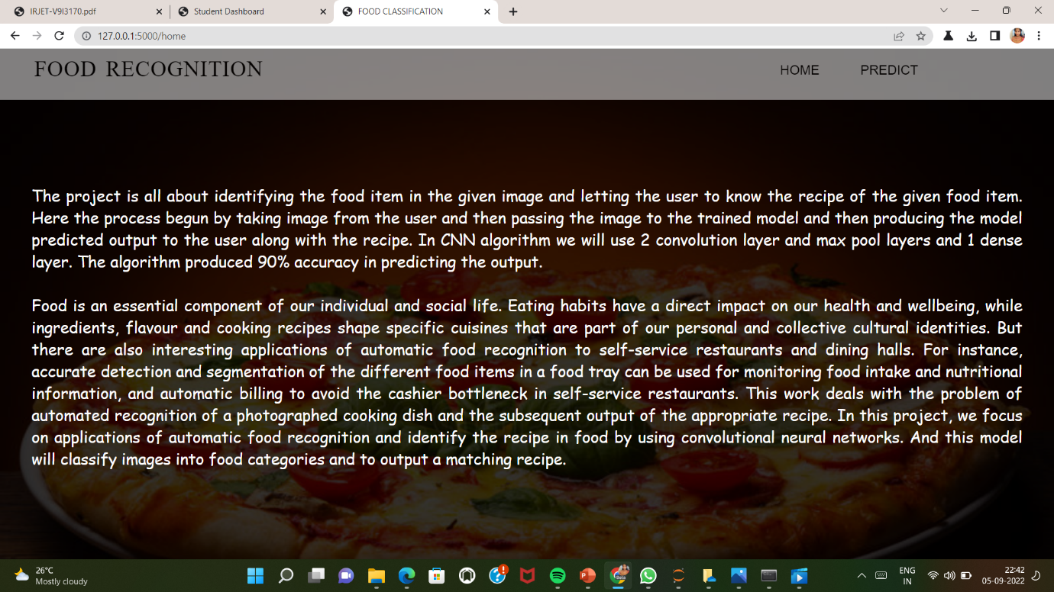

FOOD RECOGNITION PAGE:

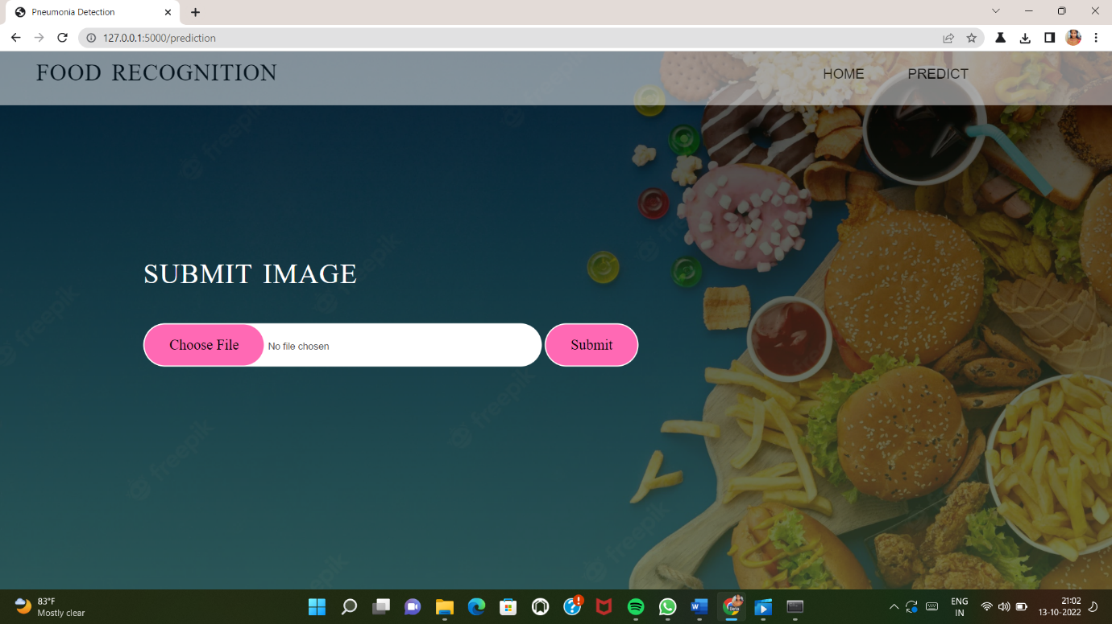

UPLOADING FRENCH FRIES IMAGE:

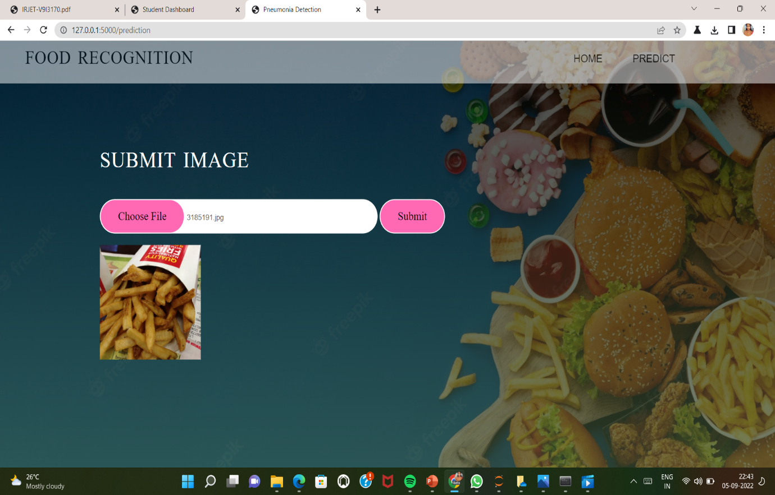

PREDICTING THE RECIPE OF THE FOOD ITEM FRENCH FRIES:

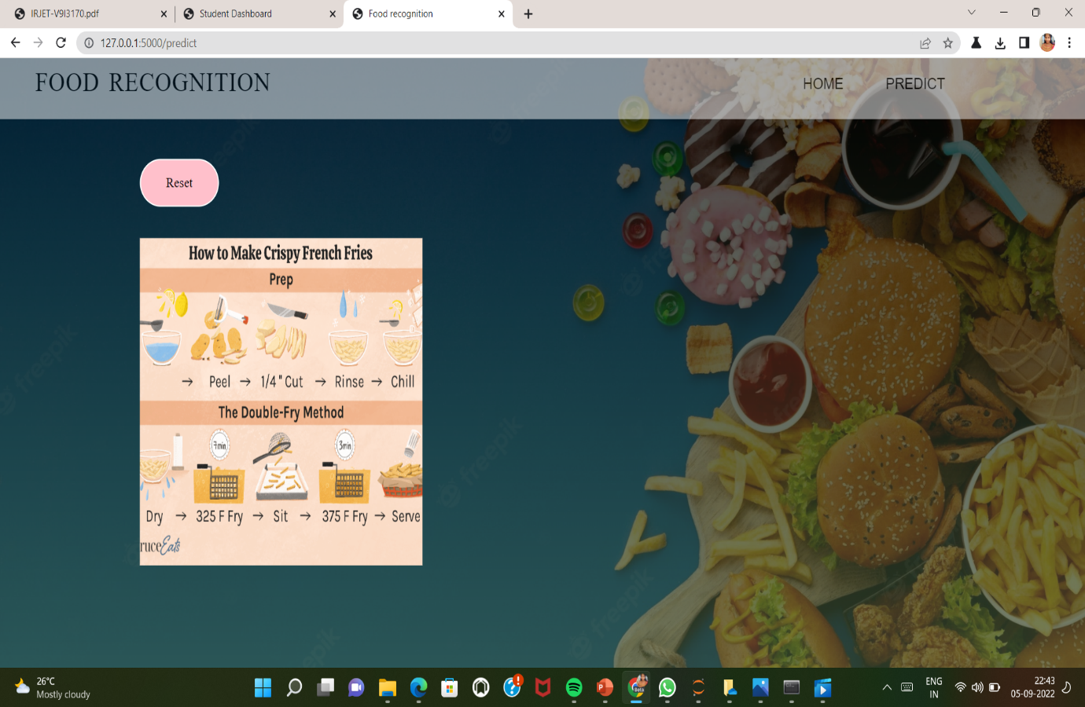

UPLOADING IMAGE OF SAMOSA:

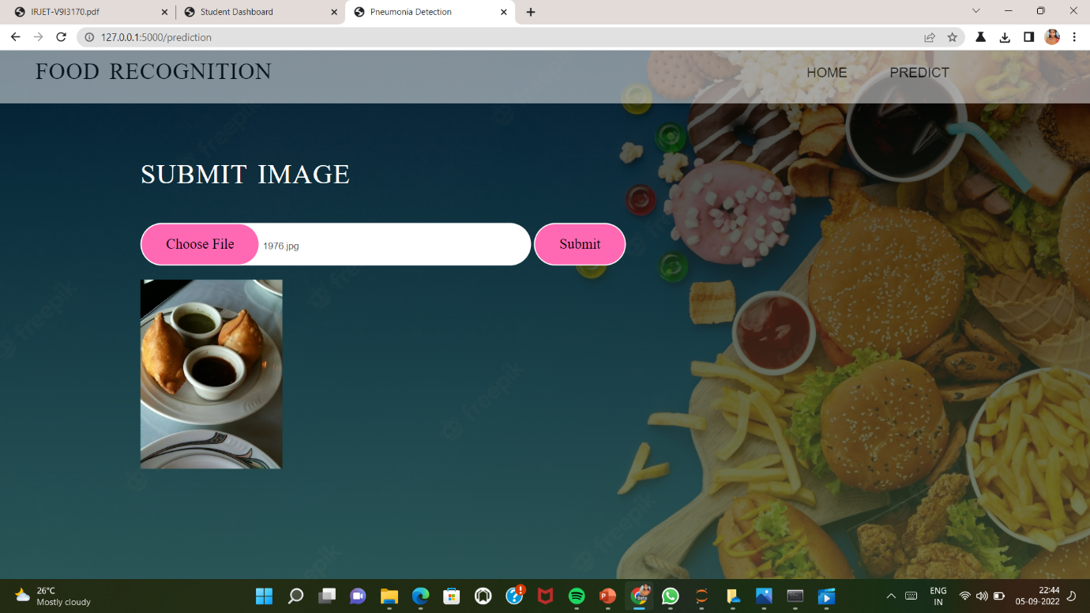

PREDECTING THE SAMOSA AND GENERATING THE RECIPE:

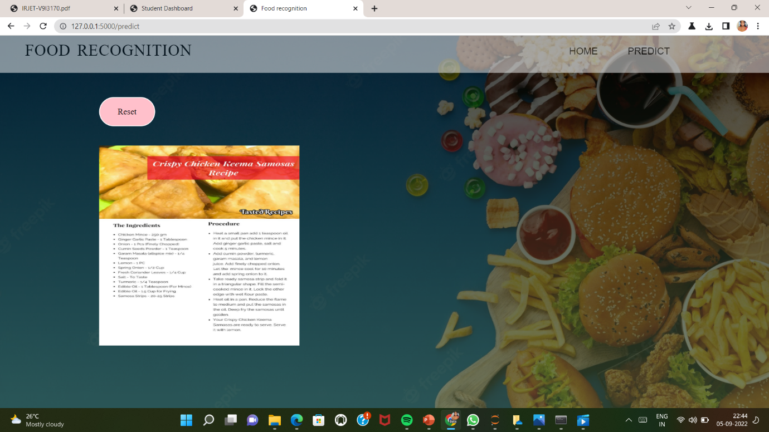

UPLOADING THE IMAGE OF PIZZA:

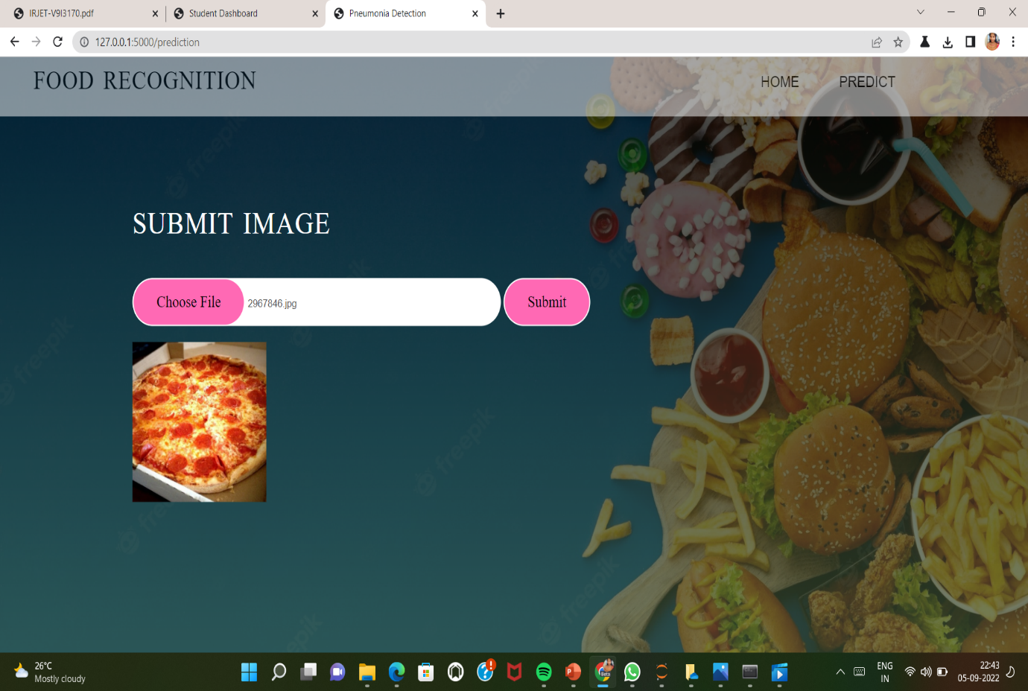

PREDICTING THE PIZZA AND GENERATING THE RECIPE OF PIZZA:

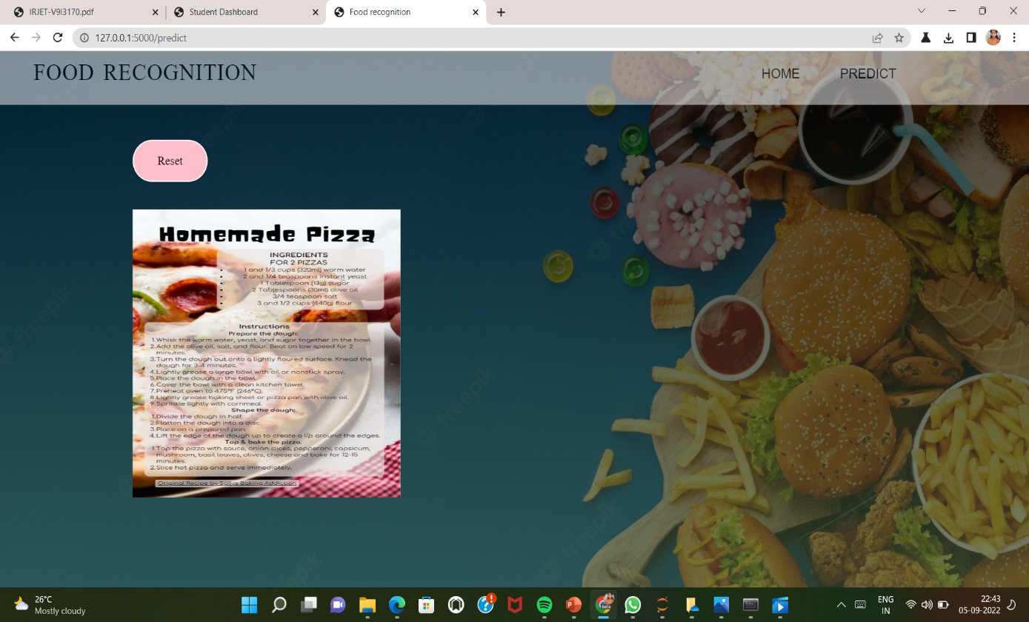

7.ADVANTAGE AND DISADVANTAGES

7.1 Advantage:

1. Provide consistent recipe of the food items that have been thoroughly tested and evaluated by using the dataset.

2. Predicting appropriate recipe.

3. Better and more effective processing model.

4. The model is fast and accurate.

7.2 Disadvantage:

1.Requries very large amount of data in order to perform better.

2.It is extremely expensive to train due to complex data models.

3.It is not easy to identify all food items. We need to collect all food items dataset.

4.It can`t identify the variations in food.

8.APPLICATIONS:

1. Service to government restaurants.

2.Food Oriented application.

3.Self service restaurants.

4.Dobo Pizza operates in a very competitive market.

9.CONCLUSION

The integration of multimodal content, context and external knowledge helps human and machines to solve complex problems. In this spirit, we have described a general intelligent framework applied to food analysis, and reviewed some recent advances in several directions, including recipe analysis, food recommendation, restaurant-oriented applications and related datasets.

10.FUTURE SCOPE

A future with even more pervasive intelligent and wearable devices, increasing obesity and cardiovascular diseases and increasing interest in discovering and understanding new foods and cuisines suggests research in this area will further develop. So can be the recognition of categories, and nutrients, and accurate the food, nutrients intake.

More structured food-related knowledge such as knowledge graphs, together with delocalized, contextualized and personalized models can also be beneficial in challenging scenarios (e.g., restaurants).

11.BIBILIOGRAPHY

[1] https://machinelearningmastery.com/

[2] <http://www.kaggle.com/>

[3] https://cloud.ibm.com/docs/create-deploy-retrain-machine-learning-mode

[4] [W. Min, B. K. Bao, S. Mei, Y. Zhu, Y. Rui, and S. Jiang, “You are what you eat: Exploring rich recipe information for cross-region food analysis,” *IEEE Transactions on Multimedia*, vol. PP, no. 99, p. 1, 2017.](https://dx.doi.org/10.1109/tmm.2017.2759499)

[5] [R. Xu, L. Herranz, S. Jiang, S. Wang, X. Song, and R. Jain, “Geolocalized modeling for dish recognition,” *IEEE Transactions on Multimedia*, vol. 17, no. 8, pp. 1187–1199, 2015.](https://dx.doi.org/10.1109/tmm.2015.2438717)

[6] Haykin S. Nejronnije seti: polnij kurs [Neural networks: full course].— Moscow, 2008. — Pp. 113, 281-330.

[7]Gonzalez R. Tsifrovaya obrabotka izobrazhenij [Digital image processing]. — Moscow, 2012. –p.1104.